CarePath: An Online Disease/Healthcare System Phase 2
CPS731 Group 1

Veezish Ahmad (501080184)

Jessica Morcos (501093695)

Barbod Salehiporva (501120154)

Table of Contents

Phase-II: System Design
  - Apply Fixes on Phase-I
  - Class Diagram (initial)
  - Discuss and Apply selected Design Pattern(s)
  - Class Diagram (update)
  - Updated Sequence Diagrams (USD)
  - Traceability (update)

Apply Fixes on Phase-I

Section | Type of Fix | Description of Corrections
1.4 Functional Requirements (FR) | Traceability consistency | Added missing cross-links between FRs and related UCs, STDs, ADs, Rs, NFRs, and As. Ensured all FRs have at least one corresponding Responsibility (R) and Use Case (UC). Added system-level FRs (FR27–FR33) with correct references to R43–R52.
 | Clarity and coverage | Rewrote traceability cells so that each FR now accurately references all components involved (e.g., FR08 now includes UC03 & UC04; FR19 includes NFR02 & A05). Ensured doctor-, database-, and admin-related FRs properly link to R and NFR tables. Ensured Database FRs were not written like NFRs.
1.5  Non-Functional Requirements  (NFR) | Cross-table alignment | Fixed missing and incomplete mappings (e.g., NFR02 → R39–R41). Linked NFR01 to all latency-related FRs and NFR06 to encryption FRs (FR16–FR17). Included missing responsibilities (R26, R29, R45–R50).
 | Performance and compliance | Mapped NFR05 to all scalability FRs (FR11, FR15, FR33) and system-level responsibilities (R24, R30, R52).
1.6 Assumptions (A) | Expanded relational mapping | Each assumption now directly links to at least  one FR, NFR, UC, and relevant R. Added proper compliance mapping (A06 ↔ HIPAA/PHIPA FRs). Clarified operational dependencies (A05 ↔ FR19, FR33, R27, R39).
 | Consistency fixes | Unified structure so every A# uses the same identifier format; ensured A08/A09 reference project and uptime-related FRs.
1.7  Responsibilities (R) | Full backward linkage | Rebuilt all traceability columns to show two-way relationships between Rs and corresponding FRs, UCs, STDs, ADs, and NFRs. Added missing entries for Admin (R35–R41) and System (R43–R52).

 | System integration fixes | System-level responsibilities (R43–R52) were reconnected to FR27–FR33 and the appropriate UCs and ADs for routing, error handling, and scaling.
1.8 Use Cases (UC) | Expanded traceability coverage | Each UC now maps to its STDs, ADs, and all related FRs, Rs, NFRs, and As. Added missing system responsibilities and included A-links (contextual assumptions) for clarity.
 | Cross-validation | Ensured that UCs correspond correctly with STDs and ADs (e.g., UC03 ↔ STD03 ↔ AD03).  Included cross-links for Admin operations (UC06, UC07).
1.12 Traceability Matrix (Final) | Full matrix restructured | Created complete forward and backward traceability from FR → UC → STD → AD → R/NFR/A. Added all missing cross-references and ensured that every FR appears at least once in each dimension.
 | Consistency across tables | Standardized all identifiers (FR##, UC##, STD##, AD##, R##, NFR##, A##). Verified all  references match their definitions in prior sections.

The traceability structure was systematically corrected to ensure end-to-end alignment between requirements, responsibilities, use cases, and design artifacts.
All tables were cross-verified to remove missing, redundant, or inconsistent references. Functional Requirements (FRs) were expanded to include their corresponding UCs, STDs, ADs, Rs, NFRs, and As, ensuring every functional element can be traced both forward (toward implementation) and backward (toward its origin).
Non-Functional Requirements (NFRs) were connected to relevant performance, compliance, and encryption responsibilities, while Assumptions (A) were mapped to the exact technical or behavioral conditions they depend upon.
Responsibilities (R) were unified across actors and components, and the System responsibilities (R43–R52) were newly connected to the internal operational FRs (FR27–FR33).
Finally, the comprehensive Traceability Matrix (Section 1.12) was rebuilt to show complete linkage between requirements, design diagrams, roles, and compliance obligations, resulting in a coherent and auditable Phase 1 document that satisfies both structural and
academic traceability standards.

Class Diagram (initial)
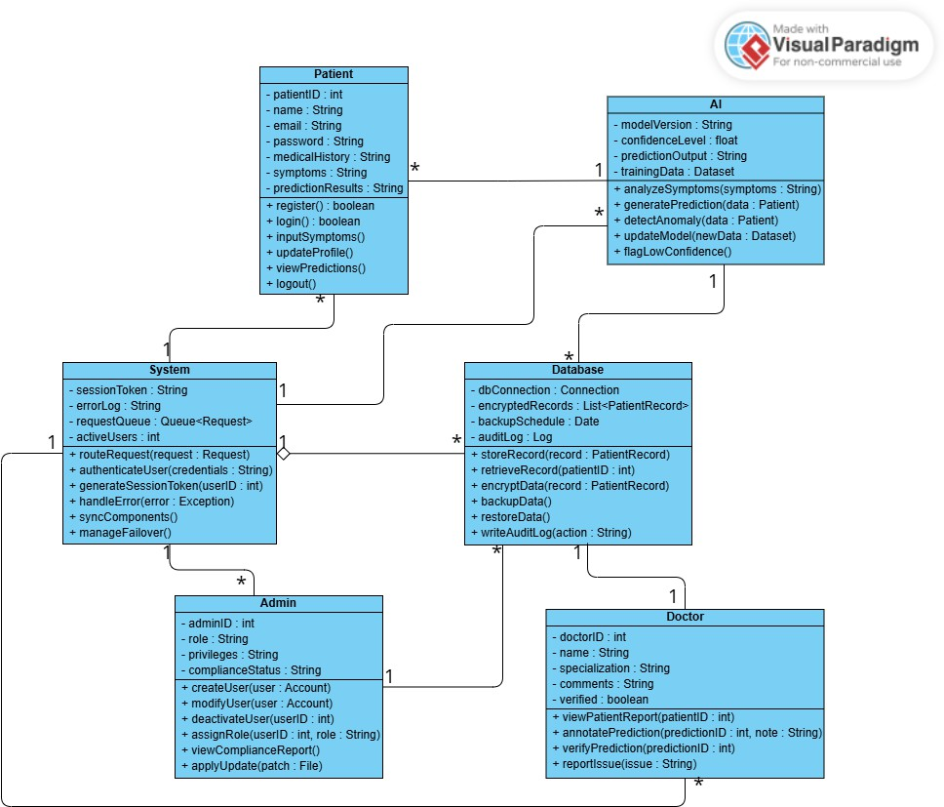

  - Discuss and Apply selected Design Pattern(s)
    - GRASP Controller – split today’s “System” into use-case controllers

      - Why: a controller is the first object after the UI that receives a system event and delegates the work to domain experts; you can use one “facade” controller for the whole system or a small controller per use case. Keeping it thin avoids a bloated god-class and supports low coupling/high cohesion.

      - How in the model: keep System as a facade and add specific controllers that call into the existing classes:

        - AuthController → login/session (FR27–FR28).

        - SymptomController → validates & routes symptom submissions (FR27, FR29).

        - PredictionController → orchestrates AI predictions/flagging (ties UC03 to AI/DB).

        - RecordsController → fetch/store patient records (FR20).

        - ComplianceController → audits/compliance operations (FR23–FR26).
    - MVC (Model–View–Controller) – make the UI independent of the domain model
      - Why: the model (the Patient/Doctor/AI/Database classes) should not depend on GUI details; controllers handle input and views subscribe to model changes. This lets you swap web/mobile UIs and have multiple views stay in sync via a propagation/dependency mechanism.
      - How in the model: treat the new use-case controllers above as the MVC “C”; “views” are the UI screens; the current classes remain the MVC “M”.
    - GRASP Information Expert – put behavior where the data lives
      - Why: assign each responsibility to the class that has the information to fulfill it; this preserves encapsulation, lowers coupling, and increases cohesion.
      - How in the model:

        - Database owns encryption/backup/audit because it has the data & facilities (FR16–FR19). Keep encryptData(), backupData(), and writeAuditLog() here.

        - AI keeps analyzeSymptoms(), generatePrediction(), flagLowConfidence() since it has the model/metrics. (Matches UC03

responsibilities listed for the system.)

        - Doctor validates/annotates predictions because they hold the clinical knowledge (FR06–FR10).

    - GRASP Creator – make the class that aggregates/uses another class create it

      - Why: A should create B if A contains/records/closely uses B or has the init data for B. This separates creation from use while keeping coupling low.

      - How in the model (introduce small value objects):

        - Patient creates SymptomEntry when entering symptoms.

        - AI creates Prediction (with confidenceLevel) when analyzing.

        - Doctor creates Annotation/Report entries when reviewing.

        - Database creates AuditLogEntry when storing/retrieving records (FR18).

        - AuthController creates SessionToken during login (FR28).

    - GRASP Low Coupling & High Cohesion – keep classes focused and independent
      - Why: fewer dependencies mean fewer ripple-effects; focused classes are easier to understand/reuse. The Controller guidance explicitly ties back to these two qualities.
      - How in the model:

        - Move errorLog/handleError() out of System into a small ErrorHandler (called by controllers); keep System/controllers delegating, not doing.

        - Keep Database focused on storage/security/audit (FR16–FR19) and avoid UI or workflow logic there.

What changes in the diagram
      - Add: AuthController, SymptomController, PredictionController, RecordsController, ComplianceController between UI and the current classes; they receive requests and forward to the right expert (per GRASP Controller).

      - Add light value objects (SymptomEntry, Prediction, Annotation, AuditLogEntry, SessionToken) and use Creator to show who instantiates them.

      - Show MVC layering: UI → Controllers → Model (the existing classes). Keep dependencies one-way from UI to Model to allow multiple UIs and synchronized views.

Why these patterns fit the specs
      - FRs already say “validate and route all incoming user requests,” “manage session tokens,” and “sync back-end components,” which are textbook controller responsibilities (FR27–FR29).
      - Data-centric FRs around storage, encryption, audit, and backup belong to the
Database as the Information Expert (FR16–FR19).

      - Splitting controllers by use case prevents a bloated controller and keeps cohesion high while coupling low.

      - Adopting MVC decouples the UI from the model so you can evolve views independently and propagate updates across views.

Class Diagram Update
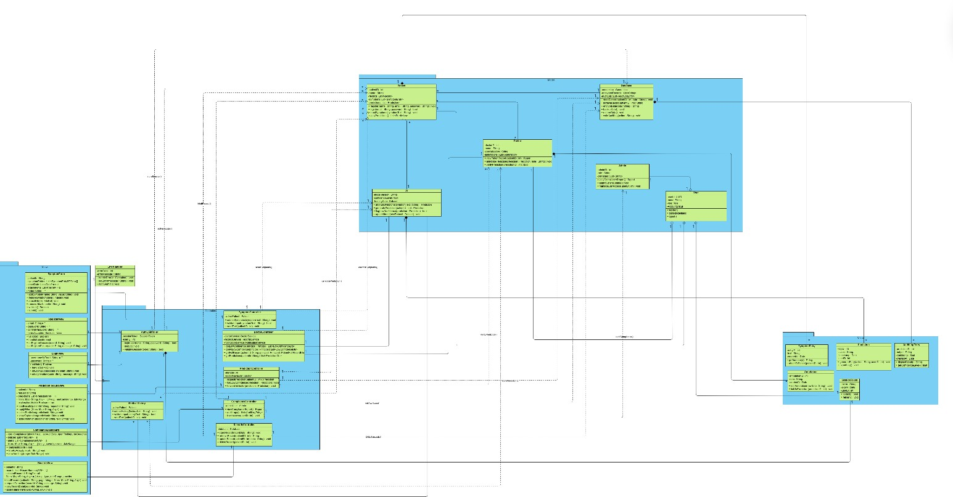



1 Model
Patient
-patientID : int
-name : String
-records: List<Record>
-symptoms: List<SymptomEntry>
-predictions : List<Prediction>
+ register(name : String, email : String, password : String) : void
+ login(email : String, password : String) : bool
+ inputSymptoms(symptomText : String) : void
+ viewPredictions() : List<Prediction>
*
* *
* *
* 1
*
* *

Doctor
*
collectsSymptoms()
1
1
+ viewPatientReport(patientID : int) : Report
+ annotatePrediction(prediction : Prediction, note : String) : void
+ verifyPrediction(predictionID : int) : bool
-doctorID : int
-name : String
-specialization : String
-annotations : List<Annotation>

* 1
1
storeSession()

1
AI

1
-modelVersion : String
-confidenceLevel : float
-trainingData : Dataset
fetchRecord()
+ analyzeSymptoms(symptomText : String) : Prediction
+ generatePrediction(patientID : int) : Prediction
+ flagLowConfidence(prediction : Prediction) : bool
+ updateModel(newDataset : Dataset) : void
1

1
1

authenticates()

1
1
+ storeRecord(patientID : int, data : String) : void
+ retrieveRecord(patientID : int) : String
+ encryptData(data : String) : String
+ backupData() : void
+ restoreData() : void
+ writeAuditLog(action : String) : void
-connection : Connection
-encryptedRecords : List<String>
-auditLog : List<AuditLogEntry>
Database
1
1
1
1

Admin
-adminID : int
-role : String
-privileges : List<String>
1
+ viewComplianceReport() : Report
+ applySystemUpdate() : void
+ manageUserAccess(userID : int) : void
1
1
-userId: UUID
-name: String
-role: Role
-AccountStatus
User

+register()
+login(credentials)
+logout()
1 1 1

Views
-errorCode : int
-errorMessage : String
ErrorHandler
SymptomForm
- patientId: String
- symptomEntries: List<SymptomEntryDTO> = []
- onsetDate: LocalDate? = null
- attachments: List<FileRef> = []
- notes: String = ""
+ addSymptom(name: String, value: String): void
+ removeSymptom(index: Integer): void
+ attachFile(file: FileRef): void
+ removeAttachment(id: String): void
+ validate(): Boolean
+ submit(): void

1
+ handleError(e : Exception) : void
+ logError(message : String) : void
+ notifyAdmin() : void

1

Controllers
1
-activePatient : Patient
sendSymptoms()

1 1
SymptomController

generatePrediction()

1 1 1
+ validate(): Boolean
+ handleSubmit(): void
+ onRegisterSuccess(userId: String): void
+ onRegisterFailure(code: String, message: String): void
- email: String = ""
- password: String = ""
- confirmPassword: String = ""
- termsAccepted: Boolean = false
RegisterView
+ submitSymptoms(symptomText : String) : void
+ validateInput(symptomText : String) : bool
+ sendToAI(patientID : int) : void
1 1
-doctorService: DoctorService
-recordsService: RecordsService
-notificationService: NotificationService
-sessionToken : SessionToken
-userID : int
DoctorController
AuthController

1
+ getLowConfidence(principal: Principal): List<LowConfidenceDto>
+ getAllLowConfidence(principal: Principal): List<LowConfidenceDto>
+ getFullRecord(patientId: String, principal: Principal): PatientFullRecordDto
+ getPredictions(patientId: String): List<PredictionDto>
+ login(username : String, password : String) : bool
+ logout() : void
+ validateSession(token : String) : bool

1 1
LoginView
- usernameOrEmail: String = ""
- password: String = ""
+ validate(): Boolean
+ handleSubmit(): void
+ onLoginSuccess(sessionToken: String): void
+ onLoginFailure(code: String, message: String): void

1
1
PredictionController
1
-aiModel : AI
-doctorReviewer : Doctor
1 1
+ requestPrediction(patientID : int) : Prediction
+ flagLowConfidence(prediction : Prediction) : void
+ forwardToDoctor(prediction : Prediction) : void
1 1
PredictionResultsView
- patientId: String
- requestId: String
- predictions: List<PredictionVM> = []
- filters: Map<String, Any> = {} // e.g., minConfidence, dateRange
- explanationVisible: Boolean = true
+ loadResults(patientId: String, requestId: String): void
+ applyFilters(filters: Map<String, Any>): void
+ selectPrediction(predictionId: String): void
+ showExplanation(predictionId: String): void
+ addAnnotation(predictionId: String, text: String): void

1
* 1 1
ComplianceController

MedicalHistory
1
+ submitHistory(historyText : String) : void
+ validateInput(historyText : String) : bool
+ sendToAI(patientID : int) : void
-activePatient : Patient
+ viewComplianceReport() : Report
+ auditLogs() : List<AuditLogEntry>
+ trackAccess(userID : int) : void
-adminUser : Admin
1

* *
-database : Database
RecordsController
1
+ storeRecord(recordData : String) : void
+ retrieveRecord(patientID : int) : String
+ updateRecord(patientID : int, data : String) : void
+ deleteRecord(patientID : int) : void
ComplianceDashboard
- kpis: ComplianceKpisVM // e.g., lastAuditDate, openFindings, slaBreaches
- policies: List<PolicyVM> = []
- alerts: List<ComplianceAlertVM> = []
- filters: Map<String, Any> = {} // e.g., severity, owner, dateRange
+ loadDashboard(): void
+ filterByPolicy(policyId: String): void
+ viewAuditLog(range: DateRange): void

1
1
1

1
+ loadRecords(patientId: String, page: Integer, filters: Map<String, Any>): void
+ requestCorrection(recordId: String, message: String): void
+ viewRecordDetail(recordId: String): void
+ applyFilters(filters: Map<String, Any>): void
- patientId: String
- records: List<RecordSummaryVM> = []
- selectedRecordId: String? = null
- filters: Map<String, Any> = {} // e.g., type, dateRange, provider
RecordsView

getAuditLogs()

CRUD records()

verifyPrediction()

storePrediction()

auditCompliance()

Value
* * *

SymptomEntry
-entryID : int
-text : String
-createdAt : Date
+ getSummary() : String

-logID : int
-action : String
-timestamp : Date
-userID : int
Prediction
AuditLogEntry
-predictionID : int
-output : String
-confidence : float
-createdAt : Date

+ attachToPatient(patientID : int) : void
+ generateEntry(action : String, userID : int) : void
+ exportLog() : void
+ displayResult() : String
+ getConfidenceLevel() : float

Annotation
-annotationID : int
-note : String
* -createdAt : Date
+ editAnnotation(newNote : String) : void
+ linkToPrediction(predictionID : int) : void

SessionToken
-token : String
-expiry : Date
1 -userID : int
+ isValid() : bool
+ refresh() : void
1

Updated Sequence Diagrams (USD)
USD01
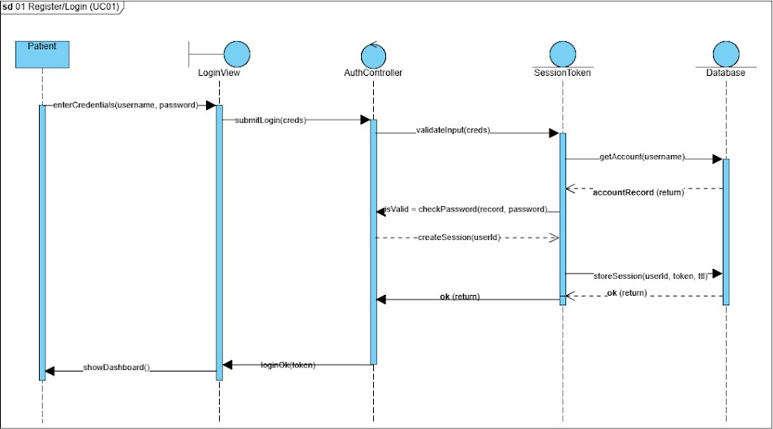

USD02
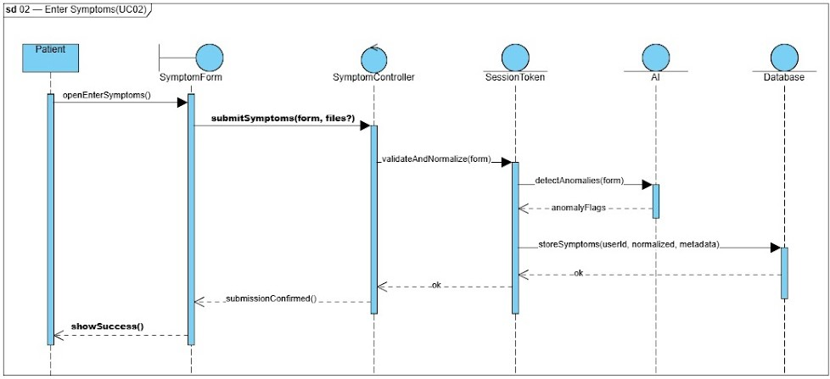

USD03
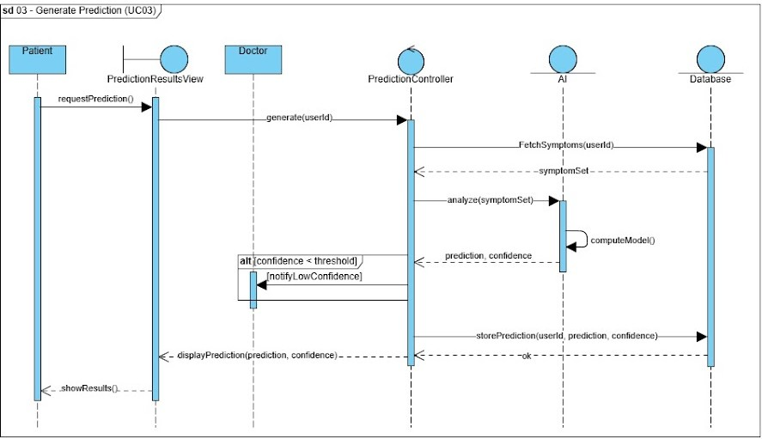
USD04
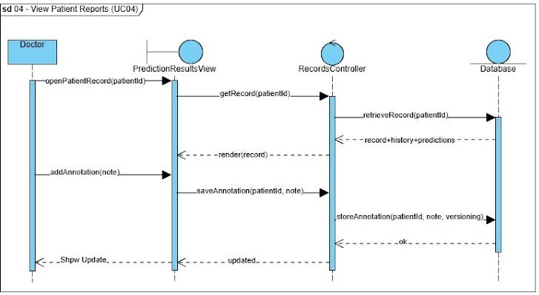

USD05
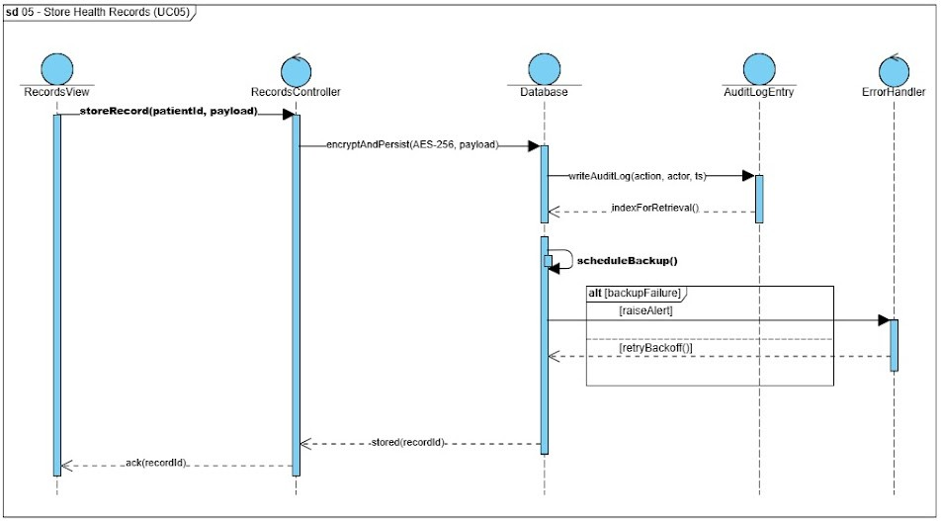
USD06
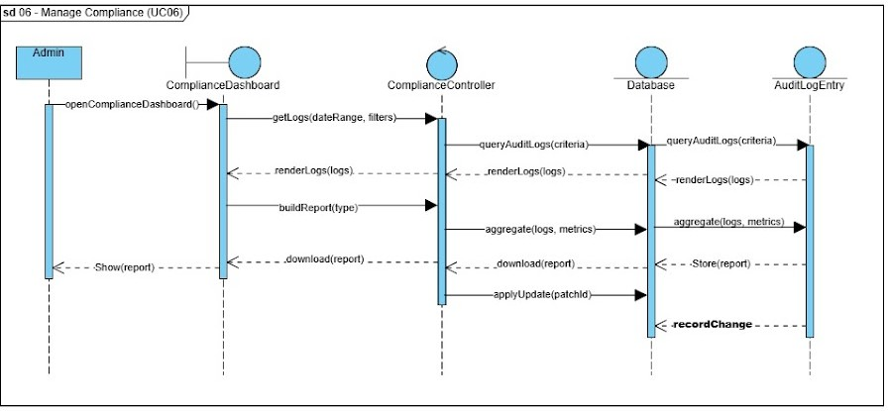

USD07
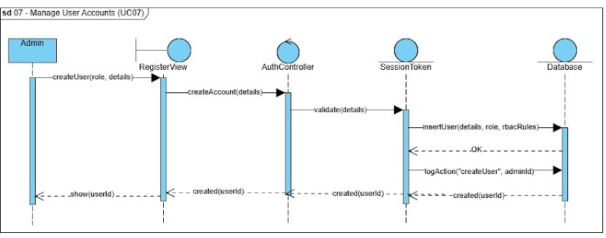
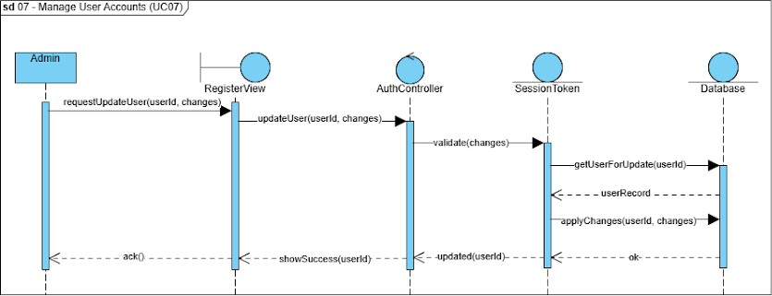

  - Traceability (update)

FR | Description | UC | STD | AD | SD / USD | R / NFR / A
FR01 | Patients can register/login securely | UC01 | STD01 | AD01 | SD01 / USD01 | R01, R08, R09, R25, R33, R45, R46 / NFR03, NFR04, NFR06  / A01, A02, A06
FR02 | Patients input symptoms for AI analysis | UC02 | STD02 | AD02 | SD02 / USD02 | R02, R03, R06, R07, R22, R25 / NFR01, NFR04  / A01, A03
FR03 | System sends abnormal reading alerts to patients | UC03 | STD03 | AD03 | SD03 / USD03 | R06, R23 / NFR01 / A01
FR04 | Patients review AI predictions | UC03 | STD03 | AD03 | SD03 / USD03 | R04, R20, R23 / NFR01 / A07
FR05 | Patients update or correct previous data | UC02 | STD02 | AD02 | SD02 / USD02 | R07, R25 / NFR01 / A03
FR06 | Doctors view and edit patient | UC04 | STD04 | AD04 | SD04 / USD04 | R09–R13, R25, R28, R32 / NFR03, NFR02
FR07 | Doctors annotate  predictions with notes | UC04 | STD04 | AD04 | SD04 / USD04 | R11, R12, R25 / NFR03 / A04

 | reports |  |  |  |  | / A04, A05
FR08 | Alert doctors on low-confidence predictions | UC03, UC04 | STD03, STD04 | AD03, AD04 | SD03–SD04  / USD03–US D04 | R14, R23, R25 / NFR01 / A04, A07
FR09 | Maintain longitudinal patient data for trends | UC04, UC05 | STD04, STD05 | AD04, AD05 | SD04–SD05  / USD04–US D05 | R09, R13, R25, R32 / NFR02 / A05
FR10 | Doctors report incorrect predictions or issues | UC04, UC06 | STD04, STD06 | AD04, AD06 | SD04–SD06  / USD04–US D06 | R14, R38 / NFR02 / A04
FR11 | Generate  possible disease predictions | UC03 | STD03 | AD03 | SD03 / USD03 | R17–R20, R23 / NFR01, NFR05  / A03, A07
FR12 | Continuously learn and refine predictions | UC03 | STD03 | AD03 | SD03 / USD03 | R18, R21 / NFR01 / A03
FR13 | Detect anomalies or  incomplete data | UC02 | STD02 | AD02 | SD02 / USD02 | R22, R25 / NFR01 / A03
FR14 | Flag  low-confidence predictions for review | UC03 | STD03 | AD03 | SD03 / USD03 | R23, R11, R14 / NFR01 / A04, A07
FR15 | Ensure prediction | UC03 | STD03 | AD03 | SD03 / USD03 | R18, R24 / NFR01, NFR05

 | response < 2 s |  |  |  |  | / A01, A05
FR16 | Store patient data securely | UC05 | STD05 | AD05 | SD05 / USD05 | R25–R29, R32 / NFR03, NFR06  / A05, A06
FR17 | Apply AES-256 encryption to  PHI | UC05 | STD05 | AD05 | SD05 / USD05 | R26, R25 / NFR03, NFR06  / A06
FR18 | Record DB operations in audit log | UC05, UC06 | STD05, STD06 | AD05, AD06 | SD05–SD06  / USD05–US D06 | R29, R35, R36 / NFR03, NFR06  / A06
FR19 | Perform automated backups and recovery | UC05 | STD05 | AD05 | SD05 / USD05 | R27, R31, R39 / NFR02 / A05, A09
FR20 | Retrieve and deliver data to  front-end users | UC04, UC05 | STD04, STD05 | AD04, AD05 | SD04–SD05  / USD04–US D05 | R25, R32 / NFR01 / A05
FR21 | Admin create, modify,  deactivate accounts | UC01, UC07 | STD01, STD07 | AD01, AD07 | SD01, SD07  / USD01, USD07 | R33, R34 / NFR03 / A08
FR22 | Assign role-based  access rights | UC07 | STD07 | AD07 | SD07 / USD07 | R34, R28, R50 / NFR03 / A08
FR23 | Monitor HIPAA/PHIPA | UC06 | STD06 | AD06 | SD06 / USD06 | R35–R37 / NFR03 / A06

 | compliance
FR24 | Conduct audits of system activity | UC06 | STD06 | AD06 | SD06 / USD06 | R36, R29 / NFR03, NFR02  / A06
FR25 | Generate  compliance and audit reports | UC06 | STD06 | AD06 | SD06 / USD06 | R36, R41, R29 / NFR03, NFR02  / A09
FR26 | Apply patches, updates, and upgrades | UC06 | STD06 | AD06 | SD06 / USD06 | R39, R40, R41 / NFR02 / A09
FR27 | Validate and  route incoming requests | UC01– UC07 | STD01– STD07 | AD01– AD07 | SD01–SD07  / USD01–US D07 | R43, R44 / NFR03 / A03
FR28 | Manage session control and tokens | UC01, UC07 | STD01, STD07 | AD01, AD07 | SD01, SD07  / USD01, USD07 | R45, R46 / NFR03 / A01
FR29 | Synchronize front-end and back-end data | UC02– UC05 | STD02– STD05 | AD02– AD05 | SD02–SD05  / USD02–US D05 | R43, R47 / NFR02 / A05
FR30 | Handle errors and show safe messages | UC01– UC07 | STD01– STD07 | AD01– AD07 | SD01–SD07  / USD01–US D07 | R48 / NFR03 / A01
FR31 | Log transactions and data exchanges | UC05– UC07 | STD05– STD07 | AD05– AD07 | SD05–SD07  / USD05–US | R49 / NFR03, NFR06 / A06

 |  |  |  |  | D07
FR32 | Enforce access control policies | UC01, UC04, UC07 | STD01, STD04, STD07 | AD01, AD04, AD07 | SD01, SD04, SD07  / USD01, USD04, USD07 | R50, R28 / NFR03 / A08
FR33 | Maintain uptime via failover  mechanisms | UC06, UC07 | STD06, STD07 | AD06, AD07 | SD06–SD07  / USD06–US D07 | R39, R51 / NFR02 / A05, A09

